Week 5 Readings
Complete the following readings early in the week:
- Read the Week 5 and 6 Online Lecture.
- Read pages 48-55 from the textbook, Peck's Atlas of Human Anatomy for the Artist.
- Read pages 56, 98-99 and Chapter 8 pages 112-121 from the textbook, Basic Figure Drawing, by Greg Albert.
- Read pages 122-127 from the textbook, Peck's Atlas of Human Anatomy for the Artist.
- Read pages 78-85 from the textbook, Peck's Atlas of Human Anatomy for the Artist and, pages 54-55, 94-95 from the textbook, Basic Figure Drawing Techniques by Greg Albert.
- Read pages 138-143 from the textbook, Peck's Atlas of Human Anatomy for the Artist.
- Read Chapter 7 pages 101-111 from the textbook Basic Figure Drawing Techniques by Greg Albert, and pages 10-21 from Peck's Atlas of Human Anatomy for the Artist.
- Read pages 91-101 from the textbook, Peck's Atlas of Human Anatomy for the Artist.
- Read page 196 from the textbook, Peck's Atlas of Human Anatomy for the Artist.
Week 5 Assignments Overview
Assignment Summary: Week 5 | Due Date
Assignment 1: Hands and Feet Life Drawing | Wednesday, August 13, 2008
Assignment 2: The Skull/Head/Neck Life Drawing | Thursday, August 14, 2008
Assignment 3: Rough Draft Full Self-Portrait, Standing or Seated | Saturday, August 16, 2008
Remember that all Assignment details can be found on the assignment pages located throughout the week. Go to those specific pages for direction on how to complete each individual assignment.

Assignment 1: Hands and Feet Life Drawing
By Wednesday, August 13, 2008, complete the following life drawing studies:
Warm Up:
Study pages 96-99 and 112-121 in Basic Figure Drawing Techniques, and do at least five sketches of the hand in motion. Study pages 93–95 in Basic Figure Drawing Techniques and do at least five sketches of the foot in motion. These should be quick (but as accurate as possible) sketches, taking less that 20 minutes.
Draw the hands and the feet from life. Depict as much of the anatomy of the hands and feet through a combination of strong line and subtle shading as you can. Use both your hands/feet and a model's if available. Time yourself and draw your close-up study drawings of the hands and feet:
• Sketch 1, 10-minute pose of the hand
• Sketch 1, 10-minute pose of the foot
Life Drawing:
Draw your own hand or your model's hand. Render as best as you can and try to indicate as much anatomy as possible. This should be a more finished drawing and should take at least 30-50 minutes.
Next, draw your own foot or your model's foot. Render as best as you can and try to indicate as much anatomy as possible. This should be a more finished drawing and should take at least 30-50 minutes.
Please post at least two studies and both final life drawings in the Discussion Area by Wednesday, August 13, 2008. Review and critique the work of at least two other students early in the week.

Example:
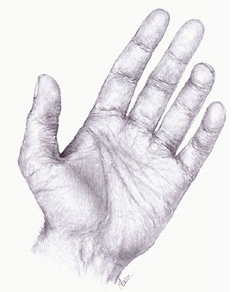
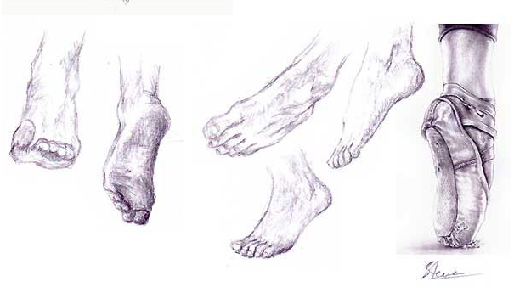
Assignment 1 Grading Criteria: | Maximum Points
Balance, scale and proportion, sketch and value, and overall unity of elements. | 6
Contour and tone. | 6
Completeness of assignment. | 6
Clean, well crafted, and technically sound work. | 6
Participated in discussion with class, feedback and comments. | 4
Total: | 28
For assistance with any problems you may have when completing this assignment—OR—to offer your assistance to classmates, please use the Problems and Solutions Discussion area located through the left side navigation link.

Assignment 2: The Skull/Head/Neck Life Drawing
Complete this assignment by Thursday, August 14, 2008, and post it to the appropriate thread in the Discussion Area. Review and critique the work of at least two other students before the end of the week.
Life Drawing
Draw a portrait of yourself or someone else. Use what you have learned from drawing the skeletal system of the skull as a guide. Spend 10-20 minutes on this drawing (this should be a sketch or study, not a "finished drawing").
Assignment 2 Grading Criteria: | Maximum Points
Balance, scale and proportion, sketch and value, and overall unity of elements. | 4
Contour and tone. | 4
Clean, well crafted, and technically sound work. | 4
Participated in discussion with class, feedback and comments. | 4
Total: | 16
For assistance with any problems you may have when completing this assignment—OR—to offer your assistance to classmates, please use the Problems and Solutions Discussion area located through the left side navigation link.

Assignment 3: Rough Draft Full Self-Portrait, Standing or Seated
For the past five weeks, you have studied proportion, anatomy and drawing from life. The end goal for this class is to have you each create a portfolio-quality, self-portrait demonstrating your knowledge of the figure.
In Week 6, you will submit a final drawing. However, you should have been thinking of possibilities along the way by examining your life drawing studies. Now, you will go one step further by submitting a rough draft for review. Your goal here is to finalize pose and composition decisions for the final.
By Saturday, August 16, 2008, submit a working rough draft for the final, and post it to the appropriate thread in the Discussion Area.
Using the approaches you have learned in previous lessons, do your warm up exercises and sketch studies of yourself standing in a variety of poses. Do not forget to think about composition in these studies! Determine which will be the pose and composition you will commit to for your final project.
For your warm up studies, follow the sequence below (posting the warm ups is not required):
Draw three 1-minute poses.
Draw three 2-minute poses.
Draw three 3-minute poses.
Draw three 5-minute poses.
Draw two 10-15-minute poses.
Next, render a draft self-portrait, depicting the entirety of the figure, including head, hands and feet. This drawing should be on a full sheet of paper (minimum 22”x30”) using as much of the surface as possible while taking care not to crop any of the figure elements off the page.
This should be a carefully rendered draft, considering composition, pose, proportion, mass, muscle and bone structure and should take at least 1 hour to complete.
Review and critique the work of at least two other students early in the week.
Assignment 3 Grading Criteria: | Maximum Points
Balance, scale and proportion, sketch and value, and overall unity of elements. | 4
Contour and tone. | 4
Clean, well crafted, and technically sound work. | 4
Participated in discussion with class, feedback and comments. | 4
Total: | 16
For assistance with any problems you may have when completing this assignment—OR—to offer your assistance to classmates, please use the Problems and Solutions Discussion area located through the left side navigation link.

